MAJOR PROJECT REPORT

“Secure Student Portal with Authentication and Web Security Controls”

Submitted To: Ediglobe

Submitted By,
Name: L V Nivethan
Batch: April Batch – Cyber Security
Submission Date: 03/06/2026

ABSTRACT
Modern web applications frequently handle sensitive user information such as login credentials and personal data. Poor implementation of authentication and security controls can expose applications to various cyber threats including SQL Injection, Cross-Site Scripting (XSS), session hijacking, and unauthorized access.
This project presents the development of a Secure Student Portal that provides user registration, login, profile management, and secure session handling. The application incorporates industry-standard security measures such as password hashing, input validation, JWT-based authentication, rate limiting, security headers, and protection against common OWASP Top 10 vulnerabilities.
The project was developed using React, Node.js, Express.js, and Supabase PostgreSQL, and deployed using Vercel.

TABLE OF CONTENTS
- Introduction
- Problem Statement
- Objectives
- System Requirements
- Technology Stack
- System Architecture
- Database Design
- Implementation Details
- Security Features Implemented
- OWASP Top 10 Mapping
- More Screenshots
- Testing
- Challenges Faced
- Future Enhancements
- Conclusion
- References

1. INTRODUCTION
Web applications are widely used across educational institutions, businesses, and online platforms. As the number of cyber threats continues to increase, it is important to ensure that web applications are developed with security in mind.
This project focuses on building a secure student portal that allows users to register, log in, and access protected resources while implementing essential cybersecurity practices. The project demonstrates how security can be integrated throughout the software development lifecycle rather than added as an afterthought.

2. PROBLEM STATEMENT
Many beginner web applications focus only on functionality and often neglect security considerations. This can result in vulnerabilities that allow attackers to gain unauthorized access, steal data, or compromise system integrity.
The objective of this project is to design and implement a secure authentication-based web application that protects against common web vulnerabilities while maintaining usability and performance.

3. OBJECTIVES
The main objectives of this project are:
- Develop a secure user registration system.
- Implement secure user authentication.
- Store passwords using strong hashing algorithms.
- Prevent SQL Injection attacks.
- Prevent Cross-Site Scripting (XSS) attacks.
- Implement secure session management using JWT.
- Restrict access to protected resources.
- Implement input validation and sanitization.
- Apply security best practices recommended by OWASP.
- Deploy the application securely on a cloud platform.

4. SYSTEM REQUIREMENTS

Hardware Requirements
- Processor: Intel i3 or higher
- RAM: 4 GB minimum
- Storage: 1 GB available space
- Internet Connection

Software Requirements
- Visual Studio Code
- Node.js
- React
- Express.js
- PostgreSQL
- Supabase
- GitHub
- Vercel
- Modern Web Browser

5. TECHNOLOGY STACK

Frontend
- React
- Bootstrap
- Axios
- React Router

Backend
- Node.js
- Express.js

Database
- Supabase PostgreSQL

Security Libraries
- bcrypt
- jsonwebtoken
- express-rate-limit
- helmet
- validator

Deployment
- Vercel
- GitHub
- Supabase

6. SYSTEM ARCHITECTURE
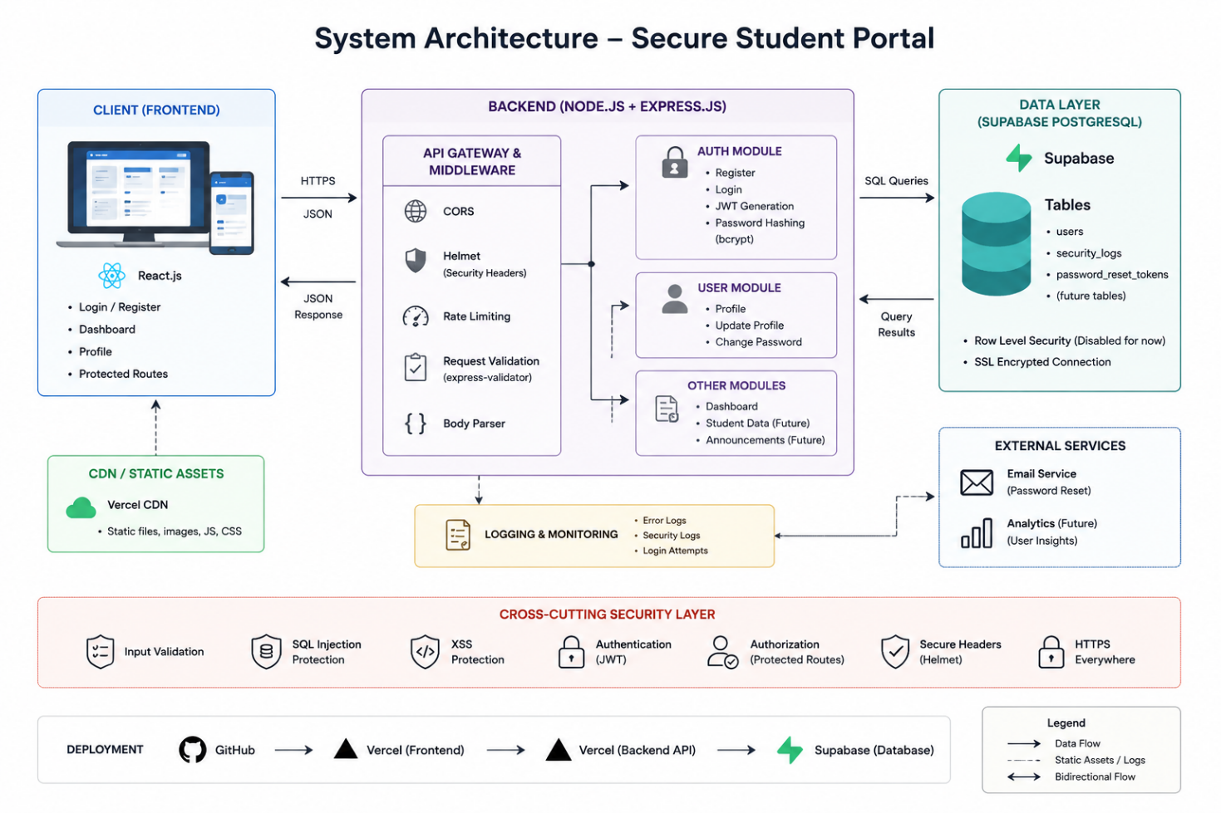

Frontend (React)
↓
Backend API (Express)
↓
Supabase PostgreSQL Database

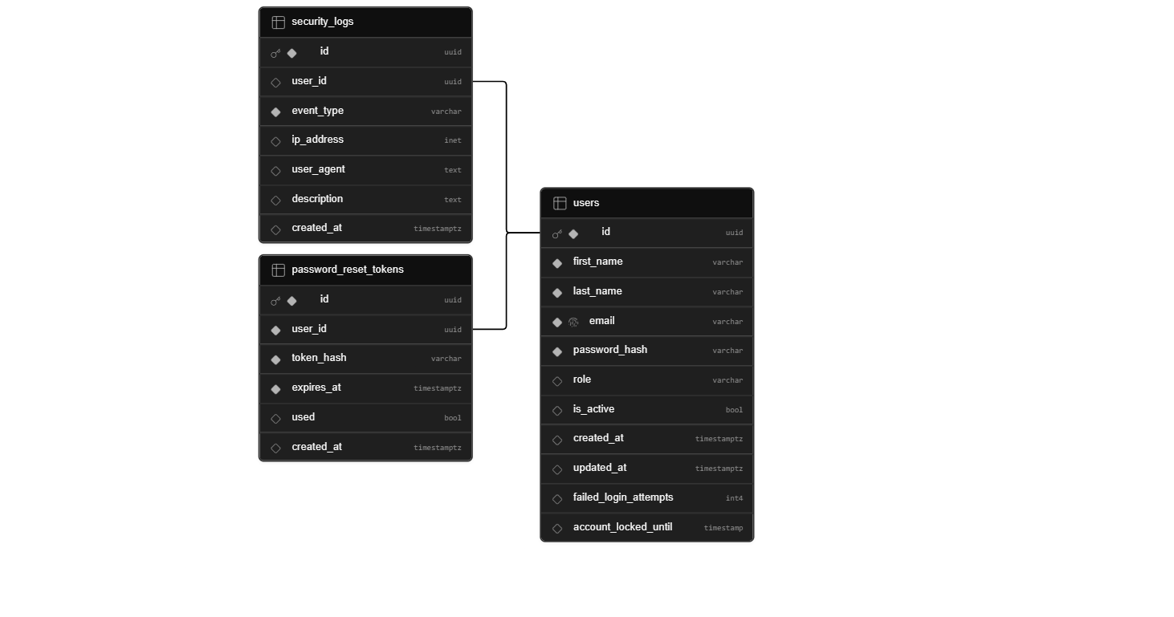
7. DATABASE DESIGN

Users Table
Column | Type
id | UUID
name | VARCHAR
email | VARCHAR
password_hash | TEXT
role | VARCHAR
created_at | TIMESTAMP

Security Logs Table
Column | Type
id | UUID
event_type | VARCHAR
user_email | VARCHAR
ip_address | VARCHAR
timestamp | TIMESTAMP

8. IMPLEMENTATION DETAILS
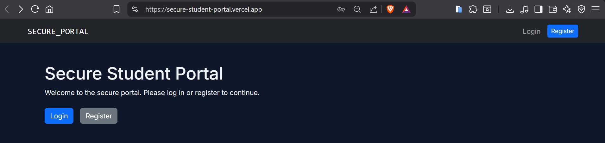

User Registration Module
Features:
- Name validation
- Email validation
- Password strength validation
- Password hashing using bcrypt
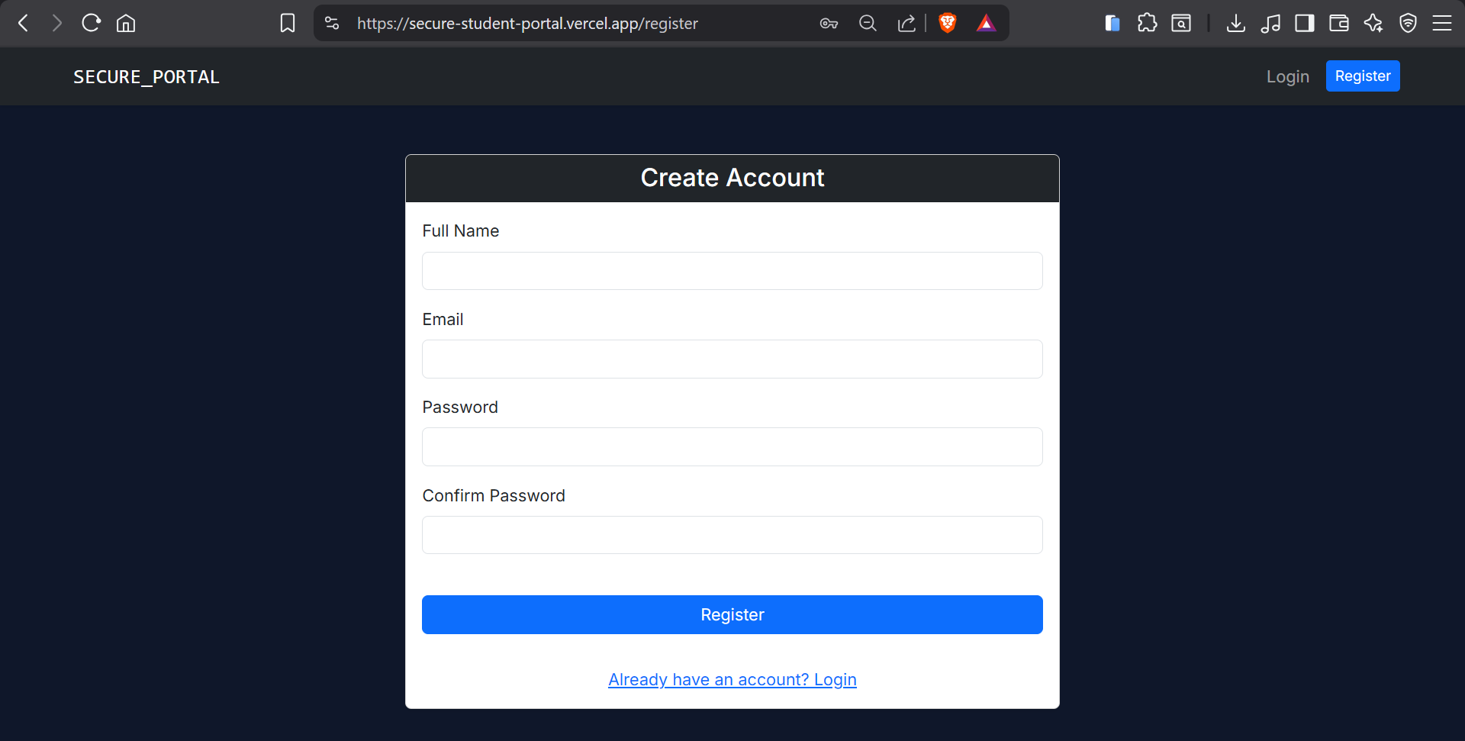

User Login Module
Features:
- Credential verification
- JWT token generation
- Secure authentication
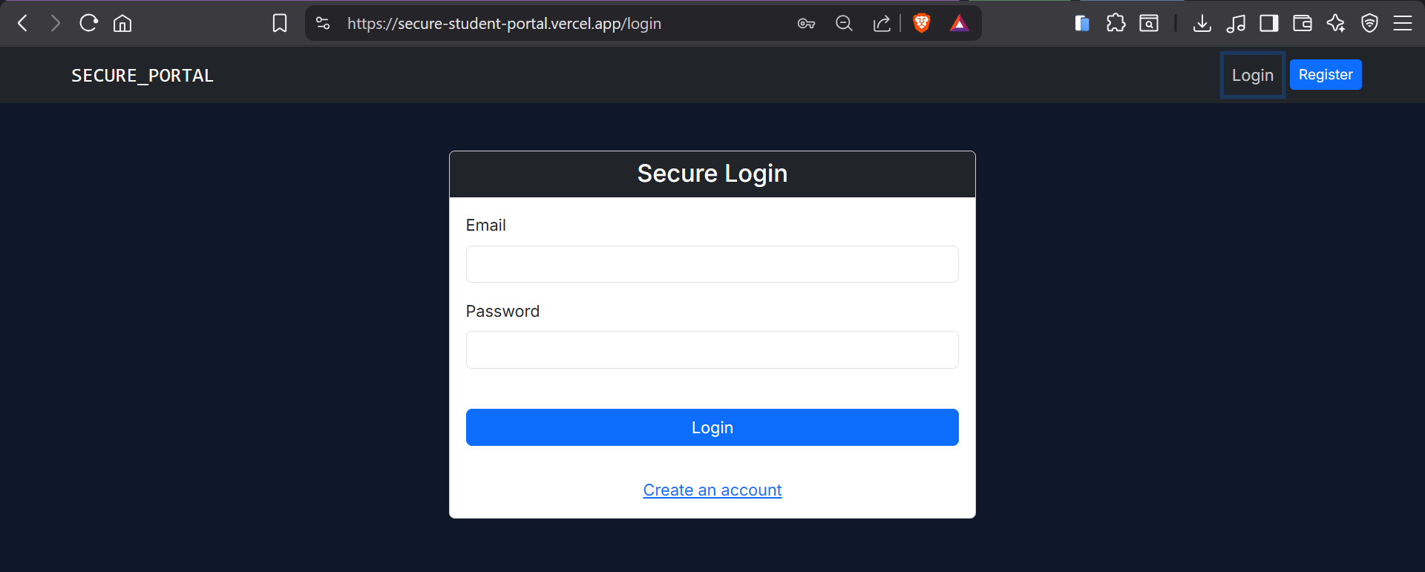

User Dashboard
Features:
- Protected routes
- Session validation
- User profile access
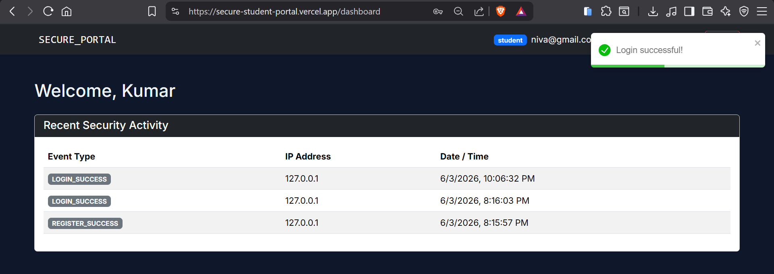

Profile Management
Features:
- Update profile details
- Secure data validation
- Authorization checks
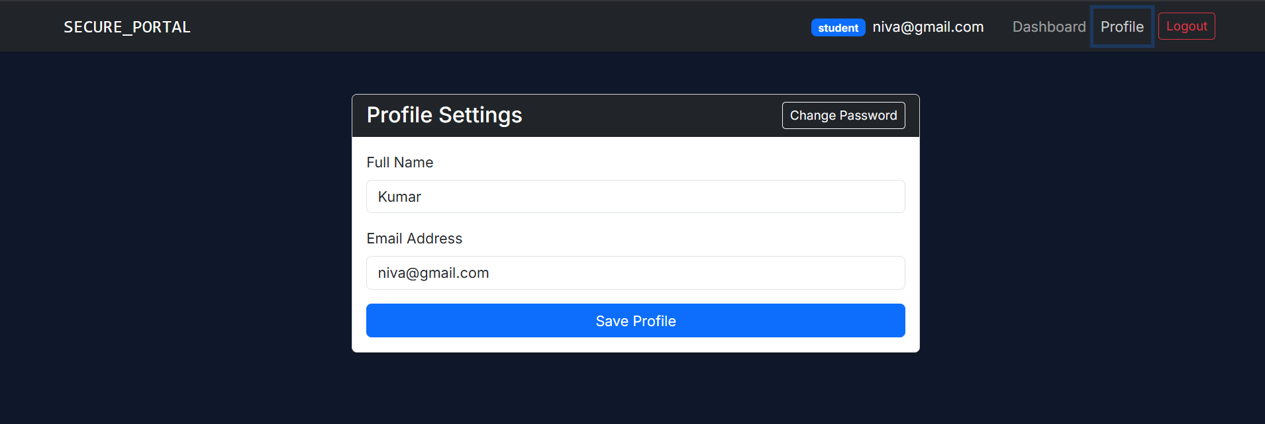

9. SECURITY FEATURES IMPLEMENTED

Password Hashing
Passwords are hashed using bcrypt before being stored in the database. Plain-text passwords are never stored.
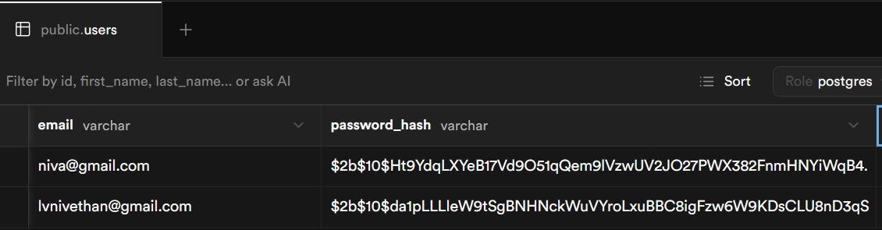

Input Validation
Both client-side and server-side validation are implemented.
Validated Fields:
- Name
- Email
- Password
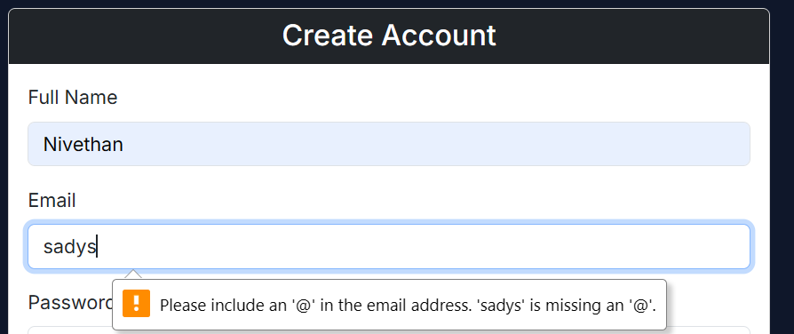
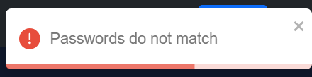
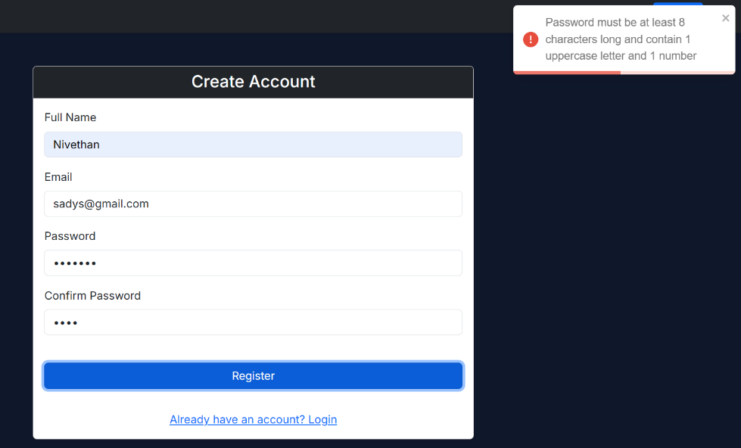

SQL Injection Prevention
Parameterized database queries are used throughout the application.
Example Attack Tested:
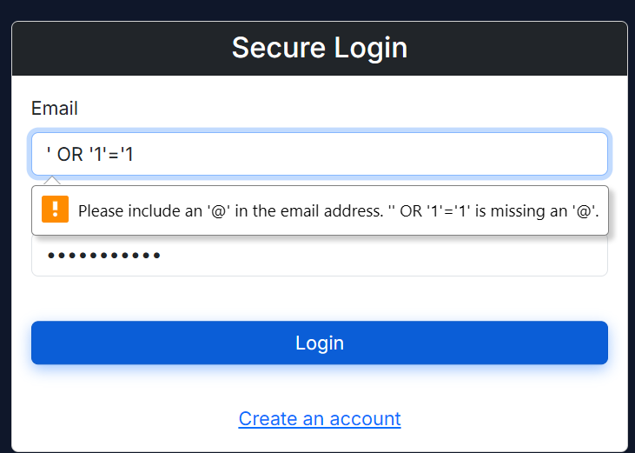
’ OR ‘1’=’1
Result:
Attack Successfully Blocked.

Cross-Site Scripting (XSS) Prevention
User input is sanitized before processing.
Example Payload:
Result:
Script Execution Prevented.
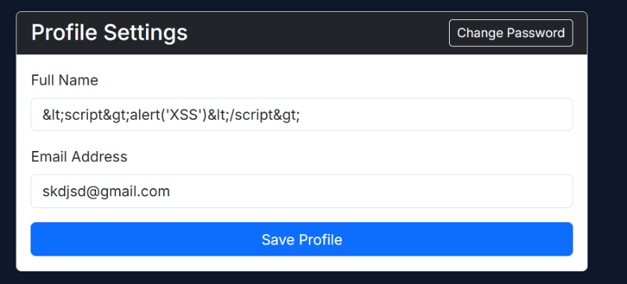
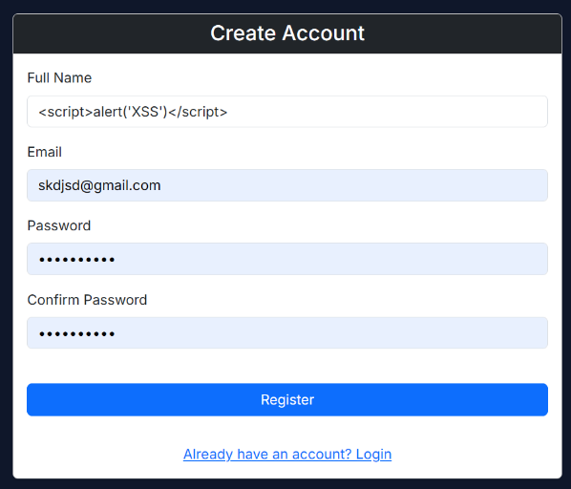

JWT Authentication
Secure JWT-based authentication is used for protected routes.
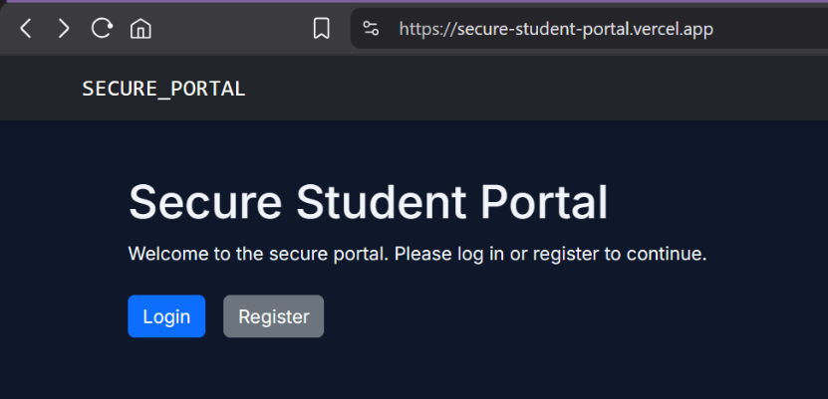
Features:
- Token Verification
- Token Expiration
- Unauthorized Access Prevention

Accessing other routes/pages is not possible without logging in to create Token in the first place.

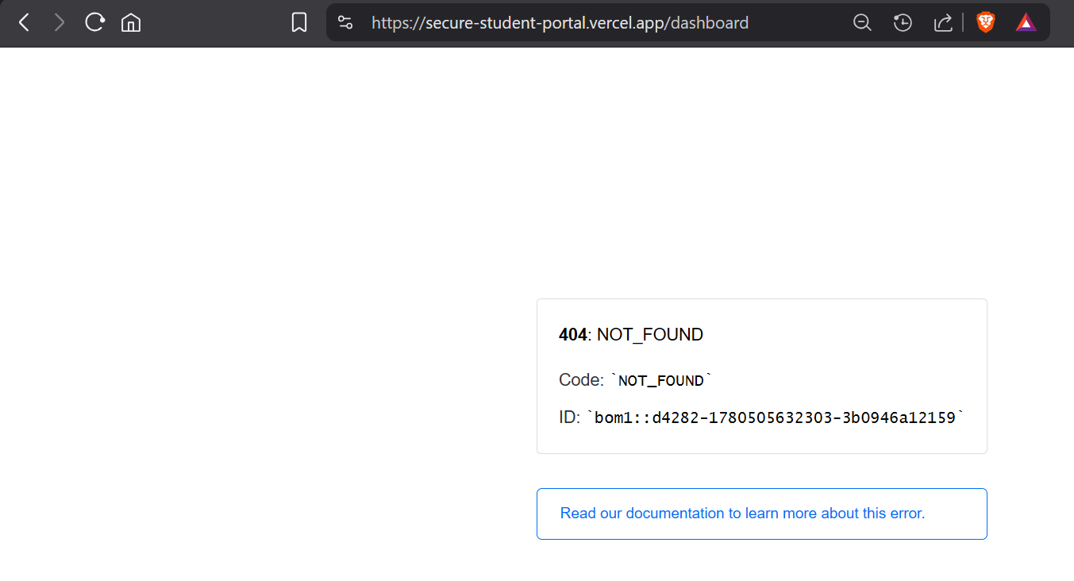
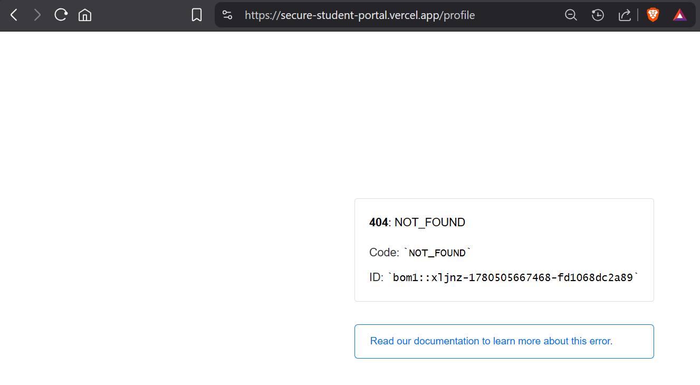

Rate Limiting
Login endpoints are protected against brute-force attacks.
Features:
- Request Limiting
- Temporary Access Restriction
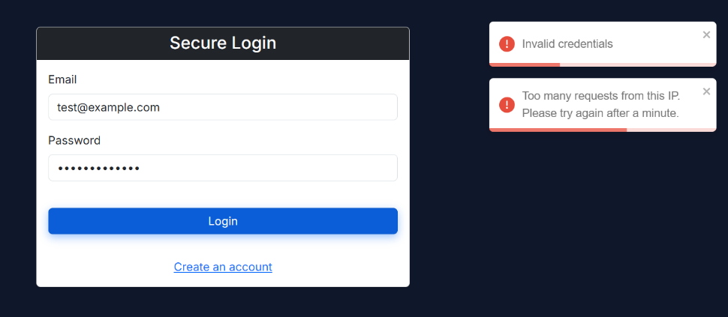

Security Headers
Implemented using Helmet middleware.
Headers Include:
- Content Security Policy
- X-Frame-Options
- X-Content-Type-Options

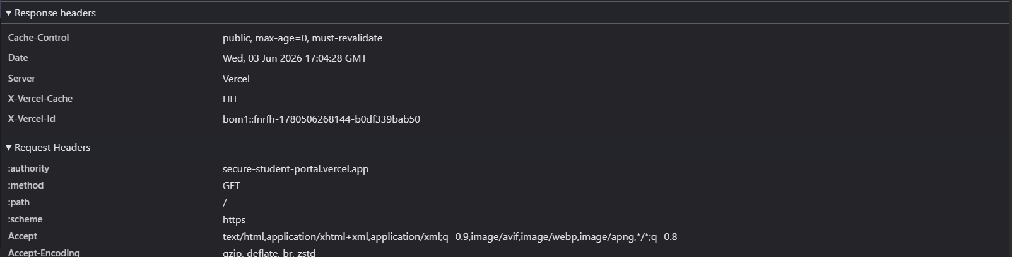

10. OWASP TOP 10 MAPPING
OWASP Risk | Mitigation Implemented
A01 Broken Access Control | Protected Routes & JWT
A02 Cryptographic Failures | bcrypt Password Hashing
A03 Injection | Parameterized Queries
A04 Insecure Design | Validation & Secure Architecture
A05 Security Misconfiguration | Helmet & Environment Variables
A06 Vulnerable Components | Updated Dependencies
A07 Authentication Failures | Strong Password Policies
A08 Software Integrity Failures | Controlled Dependencies
A09 Logging Failures | Security Logging
A10 SSRF | No External URL Processing

11. MORE SCREENSHOTS

Backend API Verification

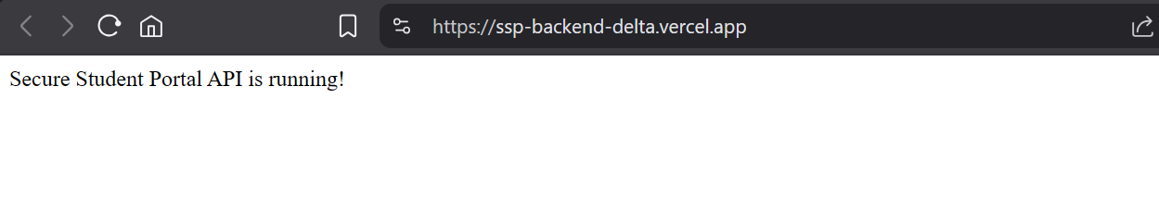

Security Logs
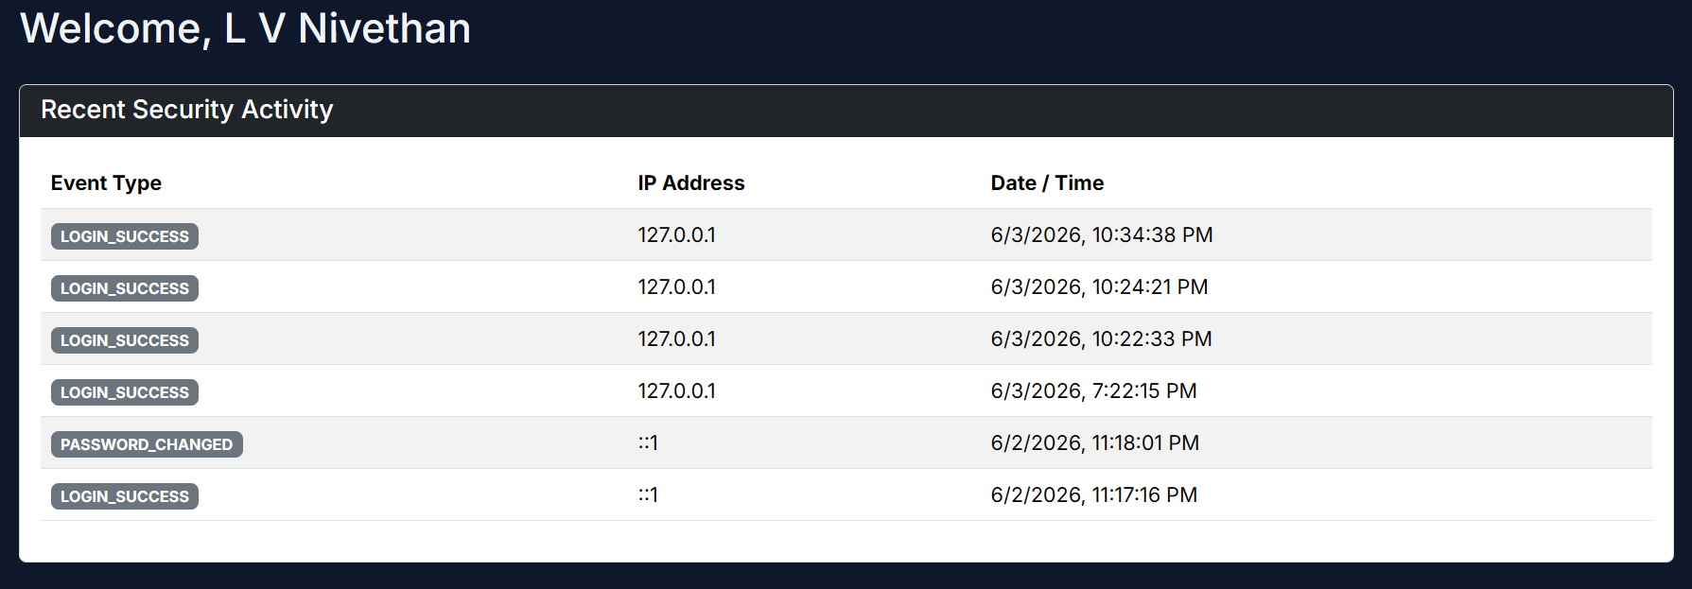

Vercel Deployment
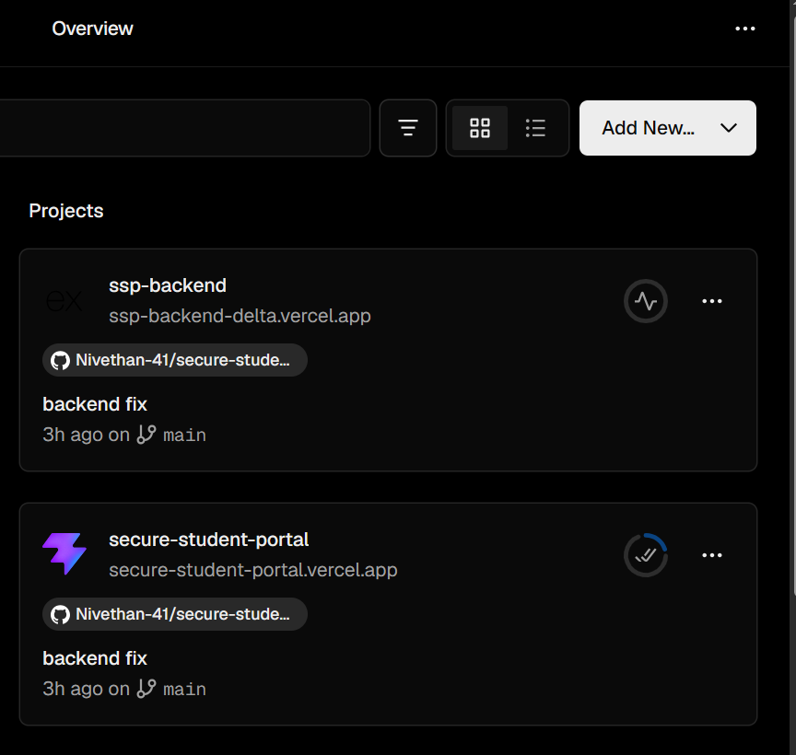

12. TESTING

Functional Testing
Test Case | Expected Result | Status
Registration | User Created | Pass
Login | Authentication Success | Pass
Logout | Session Ends | Pass
Profile Update | Data Updated | Pass

Security Testing
Security Test | Result
SQL Injection | Prevented
XSS | Prevented
Unauthorized Access | Prevented
Invalid JWT | Rejected
Brute Force Attempts | Rate Limited

13. CHALLENGES FACED
- Configuring secure authentication.
- Managing JWT sessions.
- Deploying frontend and backend separately.
- Connecting Supabase with Express.
- Handling CORS configuration.
- Testing security controls effectively.

14. FUTURE ENHANCEMENTS
- Multi-Factor Authentication (MFA)
- Password Reset via Email
- Account Recovery Mechanism
- Admin Dashboard
- Advanced Audit Logging
- Security Monitoring Dashboard
- Role-Based Access Control

15. CONCLUSION
The Secure Student Portal project successfully demonstrates secure web application development practices. The application implements authentication, authorization, password hashing, session management, input validation, and protection against common web vulnerabilities.
The project highlights the importance of integrating security throughout the development lifecycle and provides practical experience in implementing cybersecurity concepts in a real-world web application.

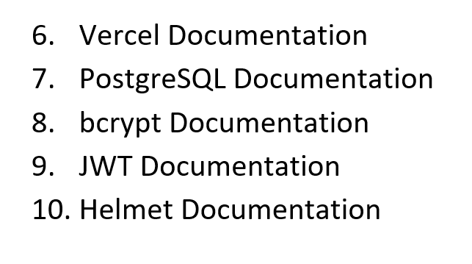
16. REFERENCES
- OWASP Top 10 Documentation
- React Documentation
- Node.js Documentation
- Express.js Documentation
- Supabase Documentation

